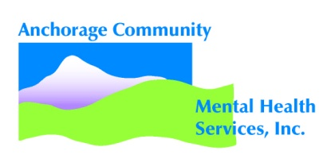
Consumer Grievance Process
It is the policy of our Organization (ACMHS/FCMHS) to treat all of our clients with dignity, respect, individuality, and with consideration for privacy. The Organization will provide all of its clients a process for reporting grievances in a respectful, timely, and fair manner without fear of retaliation.

1. Clients are asked and encouraged to review the form entitled Client Rights and Responsibilities. This form will be signed by the client at intake.

2. Clients or family members may ask someone to help them and be present during any/all grievance meetings. If asked, the Organization will provide help to clients who wish to file grievances.

3. The Organization will provide helpful resources to clients interested in filing grievances including the Disability Law Center, the Alaska Mental Health Consumer Web, NAMI Anchorage, NAMI Fairbanks, and NAMI Alaska, or any other known resource.

4. Clients are encouraged to talk about any concerns or grievances they have about their care and treatment at this Organization with their primary provider and/or that person’s supervisor to work to fix the issue. If the problem cannot be fixed as described above, the client should fill out the Consumer Complaint form and submit it in a sealed envelope to the Deputy Privacy Officer.

5. The Deputy Privacy Officer will send a letter to the client within five (5) working days of receiving the complaint if not resolved at the departmental level. The letter will inform the client that the complaint has escalated to a grievance, has been received and the review process has been started. A written response to the grievance will be provided within thirty (30) working days after the review begins. If unable to resolve the grievance in thirty (30) working days, the Deputy Privacy Officer will explain the delay to the client in writing or by phone call.

6. For clients receiving publicly funded services, grievances unresolved to the client’s satisfaction within thirty (30) calendar days shall be reported to the Division of Behavioral Health (1-800-770-3930 or 907-269-3600). Individuals may file a complaint with the Organization and the Secretary of the U.S. Department of Health and Human Services if they believe their privacy rights have been violated.

7. We have a “no tolerance” policy for abuse, neglect or intimidation being used to stop the filing of a grievance. We also do not tolerate retaliation for filing a grievance. Any report of abuse, neglect, or threats will be looked into and immediately reported to the Chief Executive Officer and the Organization’s Board of Directors through the Corporate Operations committee. For clients receiving publicly funded services, the same will be reported to the Division of Behavioral Health.

8. The Client Grievance procedure will:
- be available to all clients, legal guardians and to those denied services;
- be summarized in a plain language form and given to the client or legal guardian and an acknowledgment signature form placed in the client’s chart;
- be prominently displayed in all Organization facilities.

9. Findings of grievances will be reported by the Deputy Privacy Officer to the Chief Executive Officer and the Organization’s Board of Directors’ Corporate Operations Committee. Reports will be a summary of all grievances received in the quarter.

